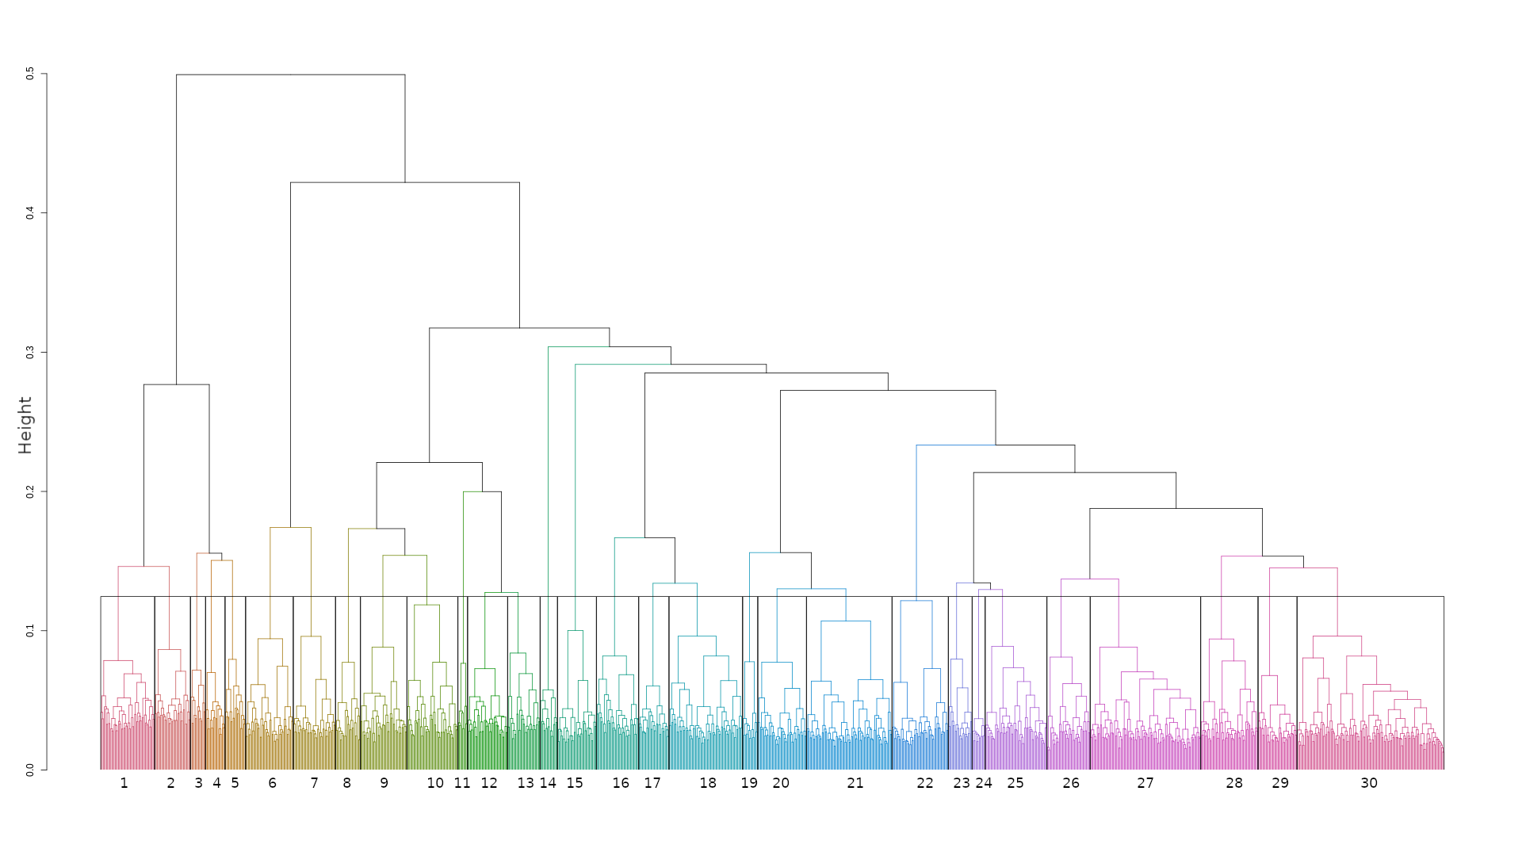

**Supplementary Figure 1**: The dendrogram shows the result of clustering the top 5000 gene pairs into 30 clusters using the ward.D2 hierarchical clustering algorithm based on the matrix of Euclidean distance between their weights.

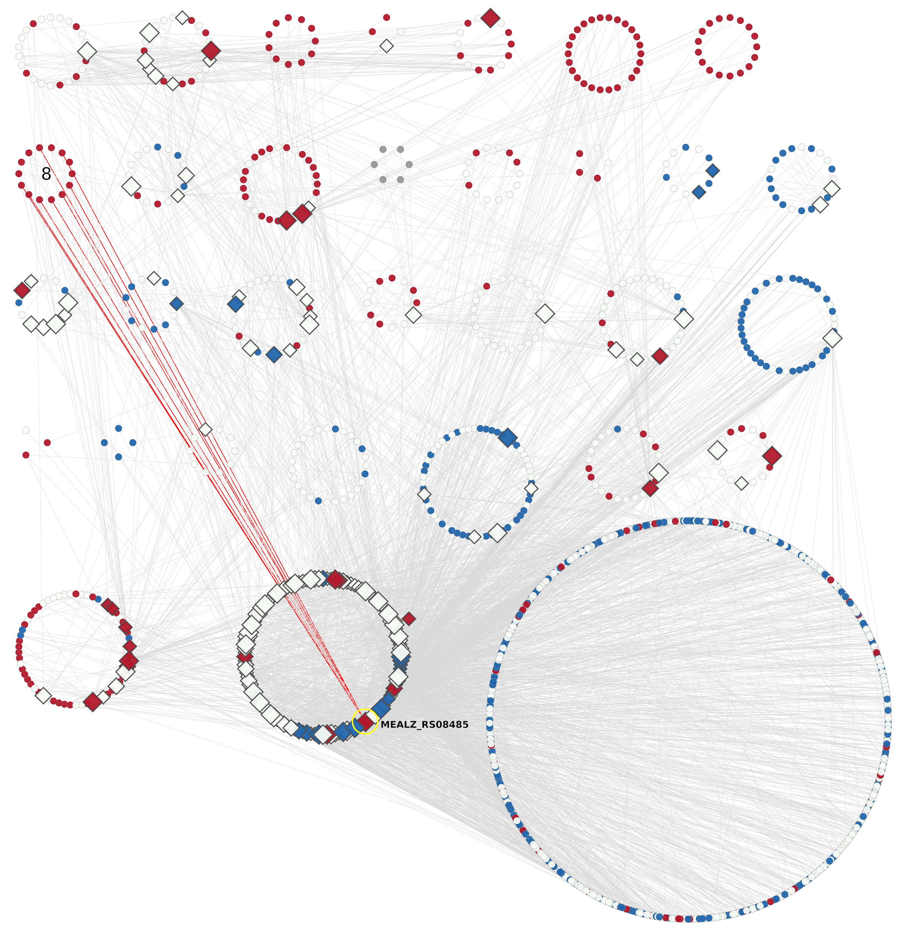

**Supplementary Figure 2:**  GRN layout based on the GCN clusters. The up-expressed genes in low O2 growth conditions are in red, while down-expressed are in blue. The up-expressed cluster 8 is designated. Clusters 31 (extra TFs) and 32 (extra non-TFs) are at the same position as in Figure 6 (main text). The extra TF (MEALZ_RS08485) which has a maximum links (red edges) with the cluster 8 is highlighted by yellow.

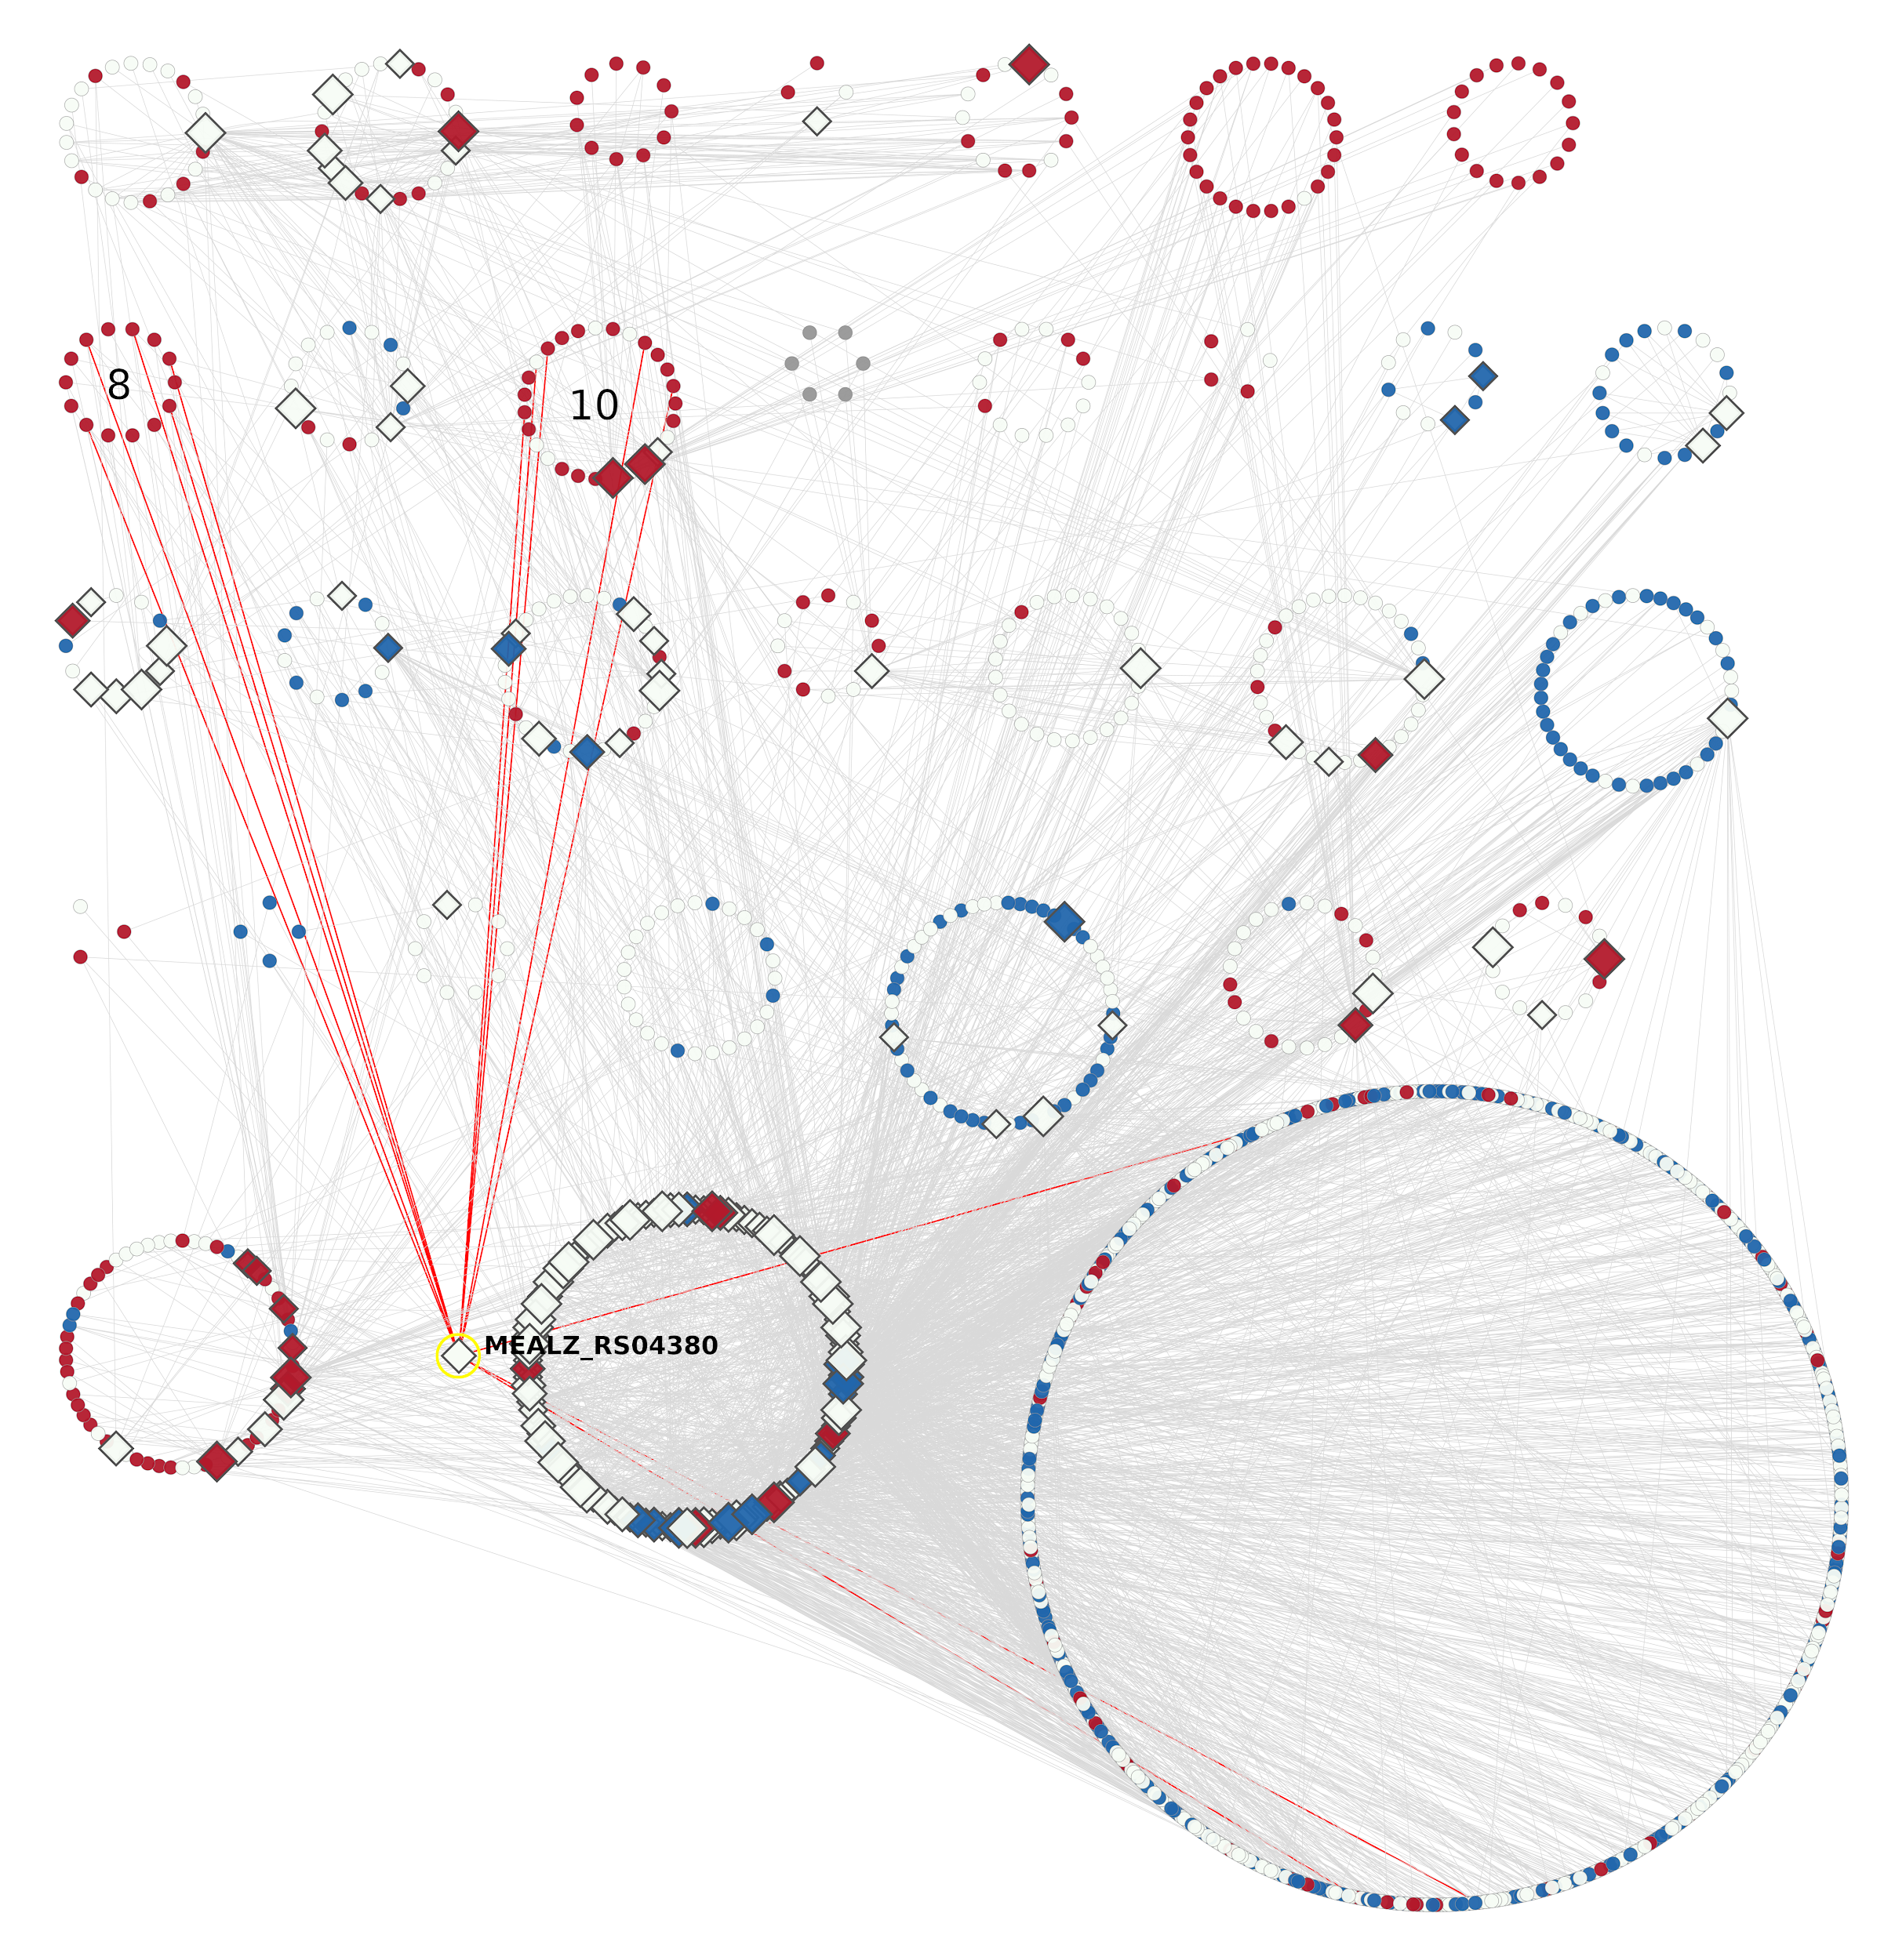

**Supplementary Figure 3:** GRN layout based on the GCN clusters. The up-expressed genes in low O2 growth conditions are in red, while down-expressed are in blue. The up-expressed clusters 8 and 10 are designated. Clusters 31 (extra TFs) and 32 (extra non-TFs) are at the same position as in Figure 6 (main text). The extra TF (MEALZ_RS04380) which has a maximum links (red edges) with the clusters 8 and 10 is highlighted by yellow.

**Supplementary Figure 4:** GRN layout based on the GCN clusters. The up-expressed genes in low O2 growth conditions are in red, while down-expressed are in blue. The down-expressed clusters 15, 22, and 27 are designated. Clusters 31 (extra TFs) and 32 (extra non-TFs) are at the same position as in Figure 6 (main text). The extra TF (MEALZ_RS04520) which has a maximum links (red edges) with the clusters 15, 22, and 27 is highlighted by yellow.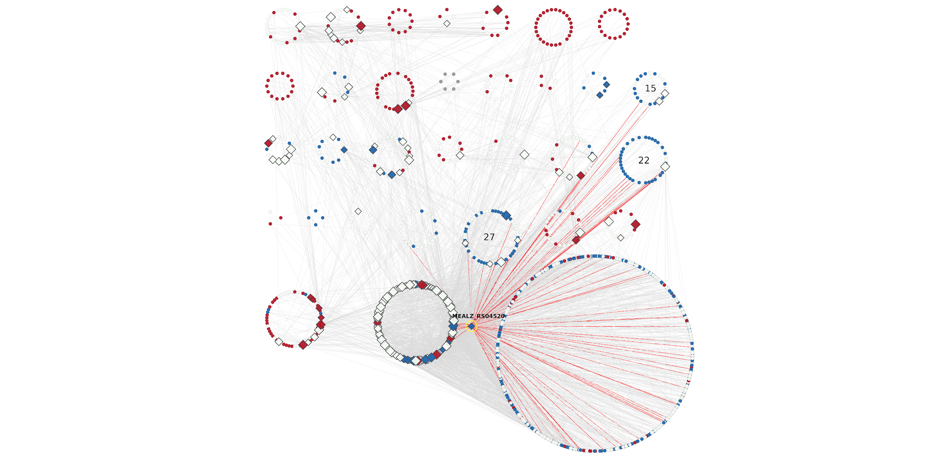

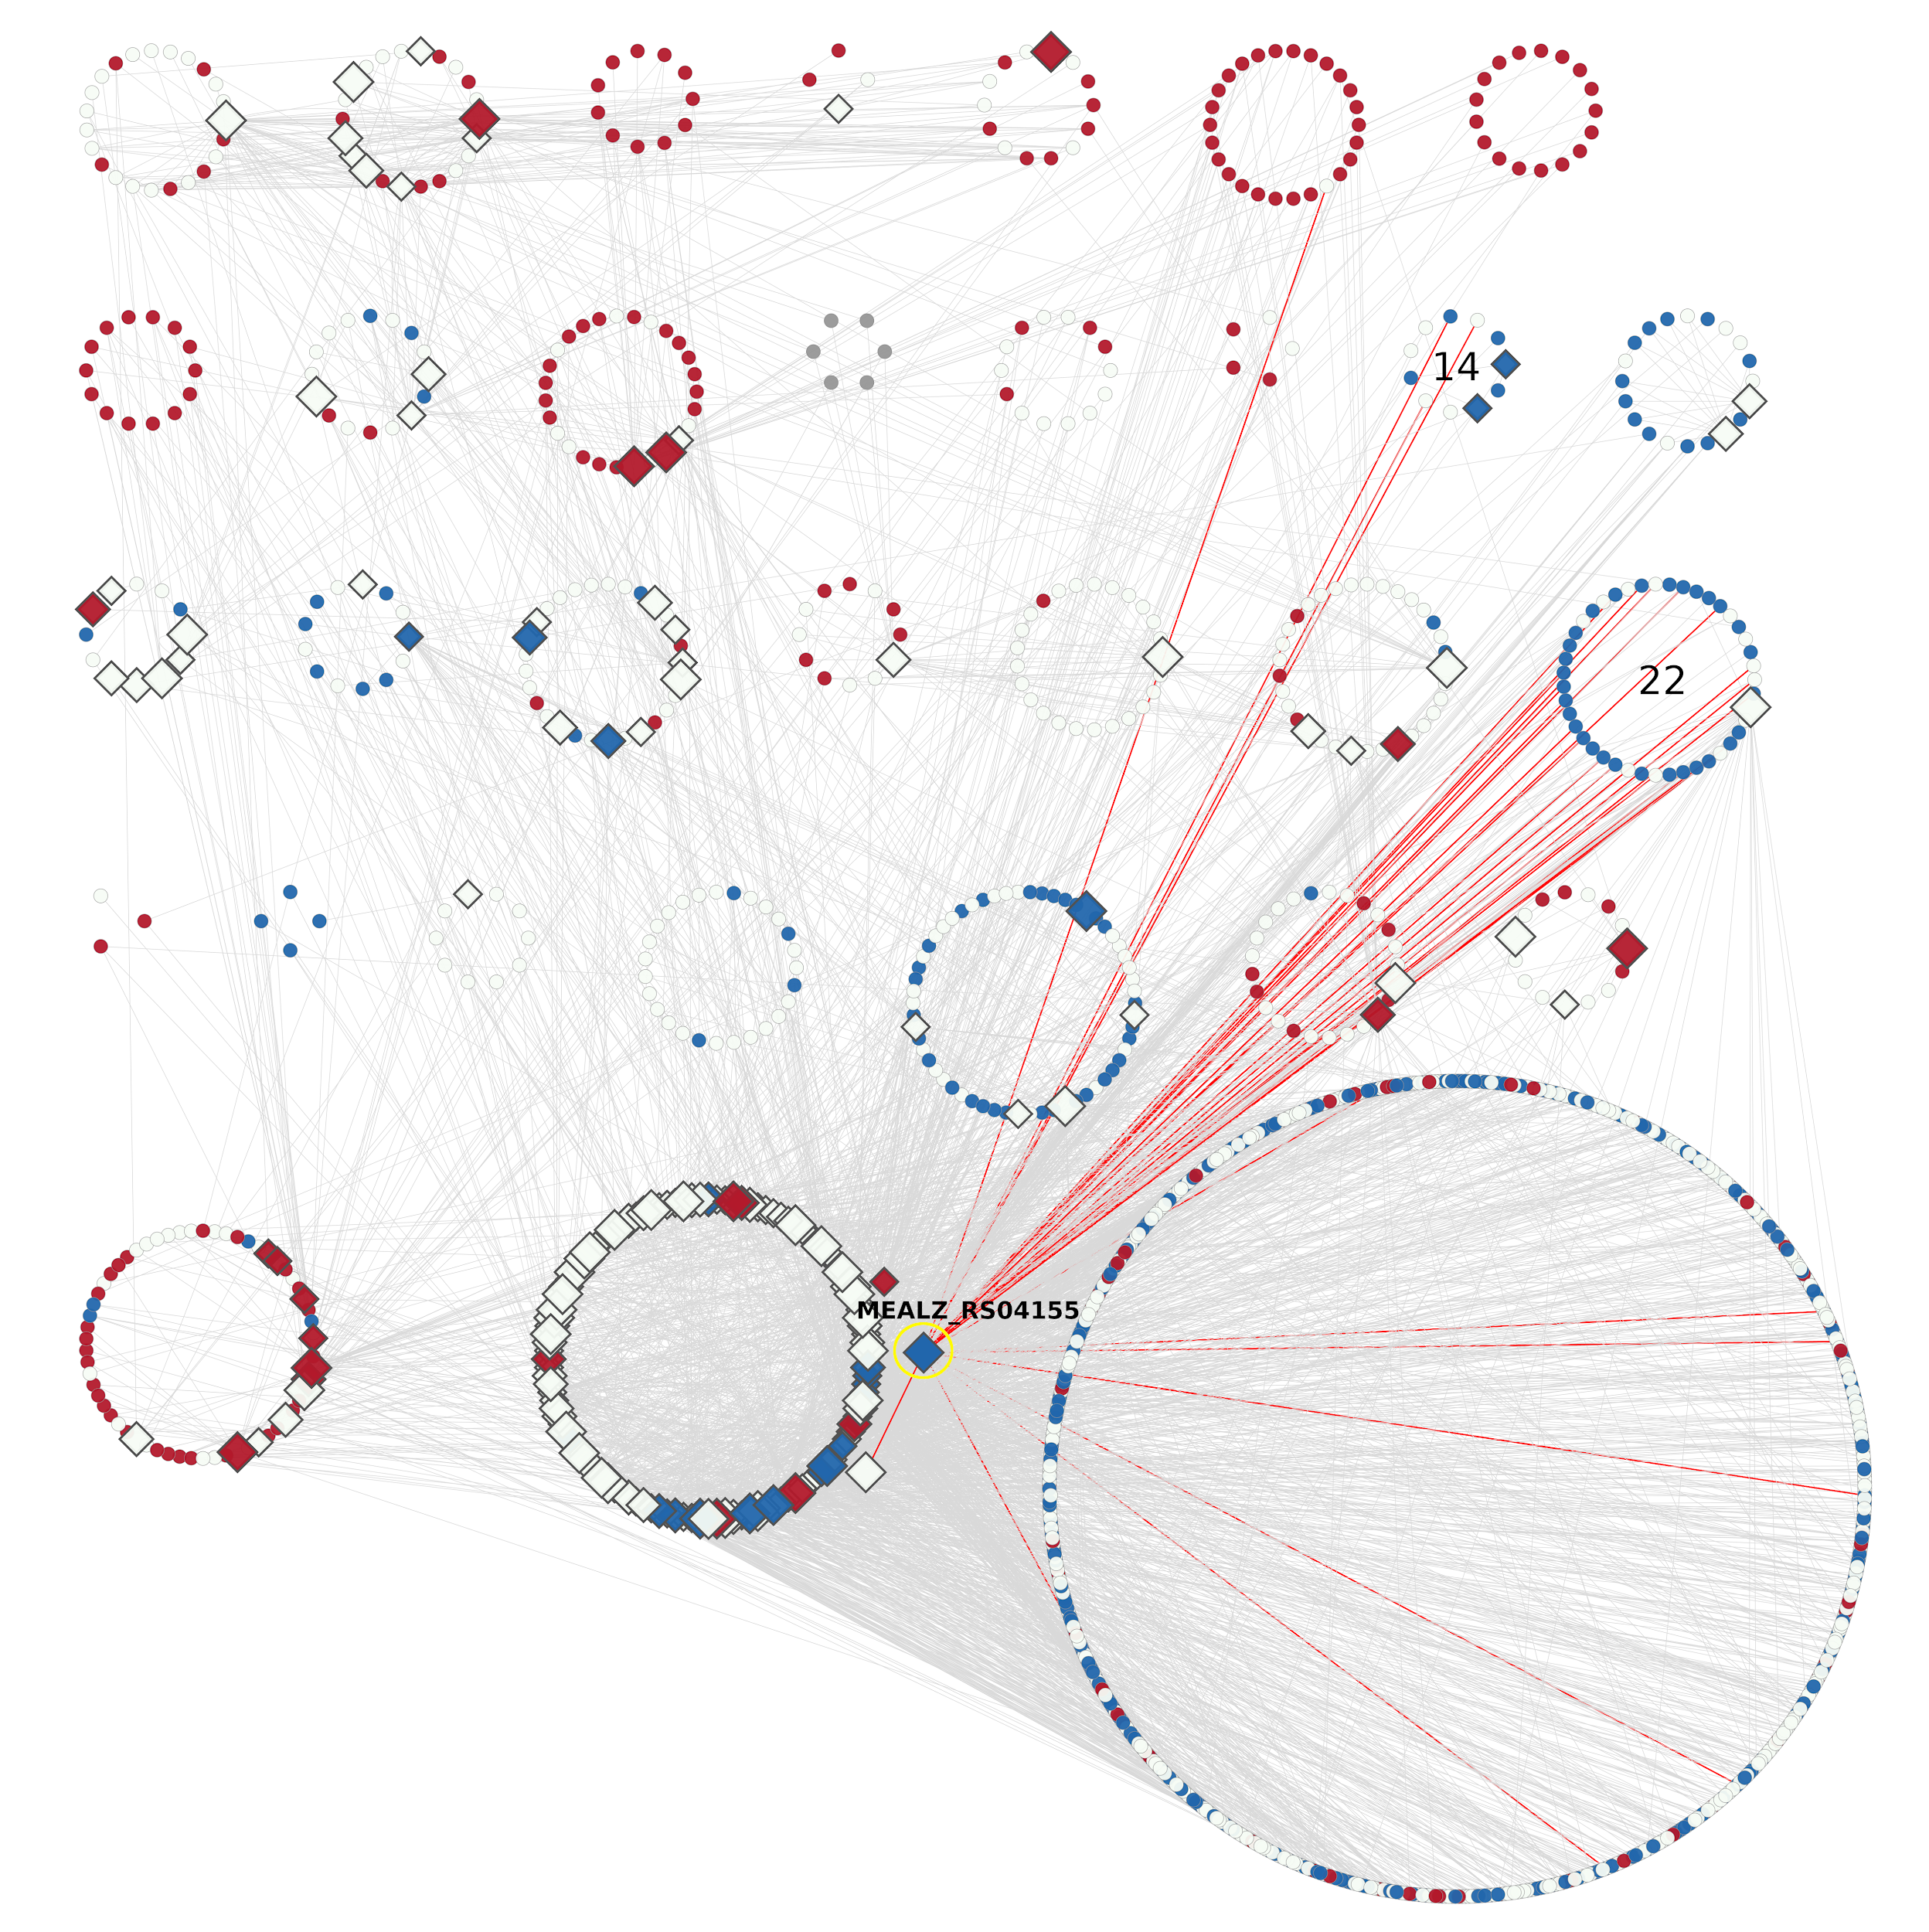

**Supplementary Figure 5:** GRN layout based on the GCN clusters. The up-expressed genes in low O2 growth conditions are in red, while down-expressed are in blue. The down-expressed clusters 14 and 22 are designated. Clusters 31 (extra TFs) and 32 (extra non-TFs) are at the same position as in Figure 6 (main text). The extra TF (MEALZ_RS04155) which has a maximum links (red edges) with the clusters 14 and 22 is highlighted by yellow.

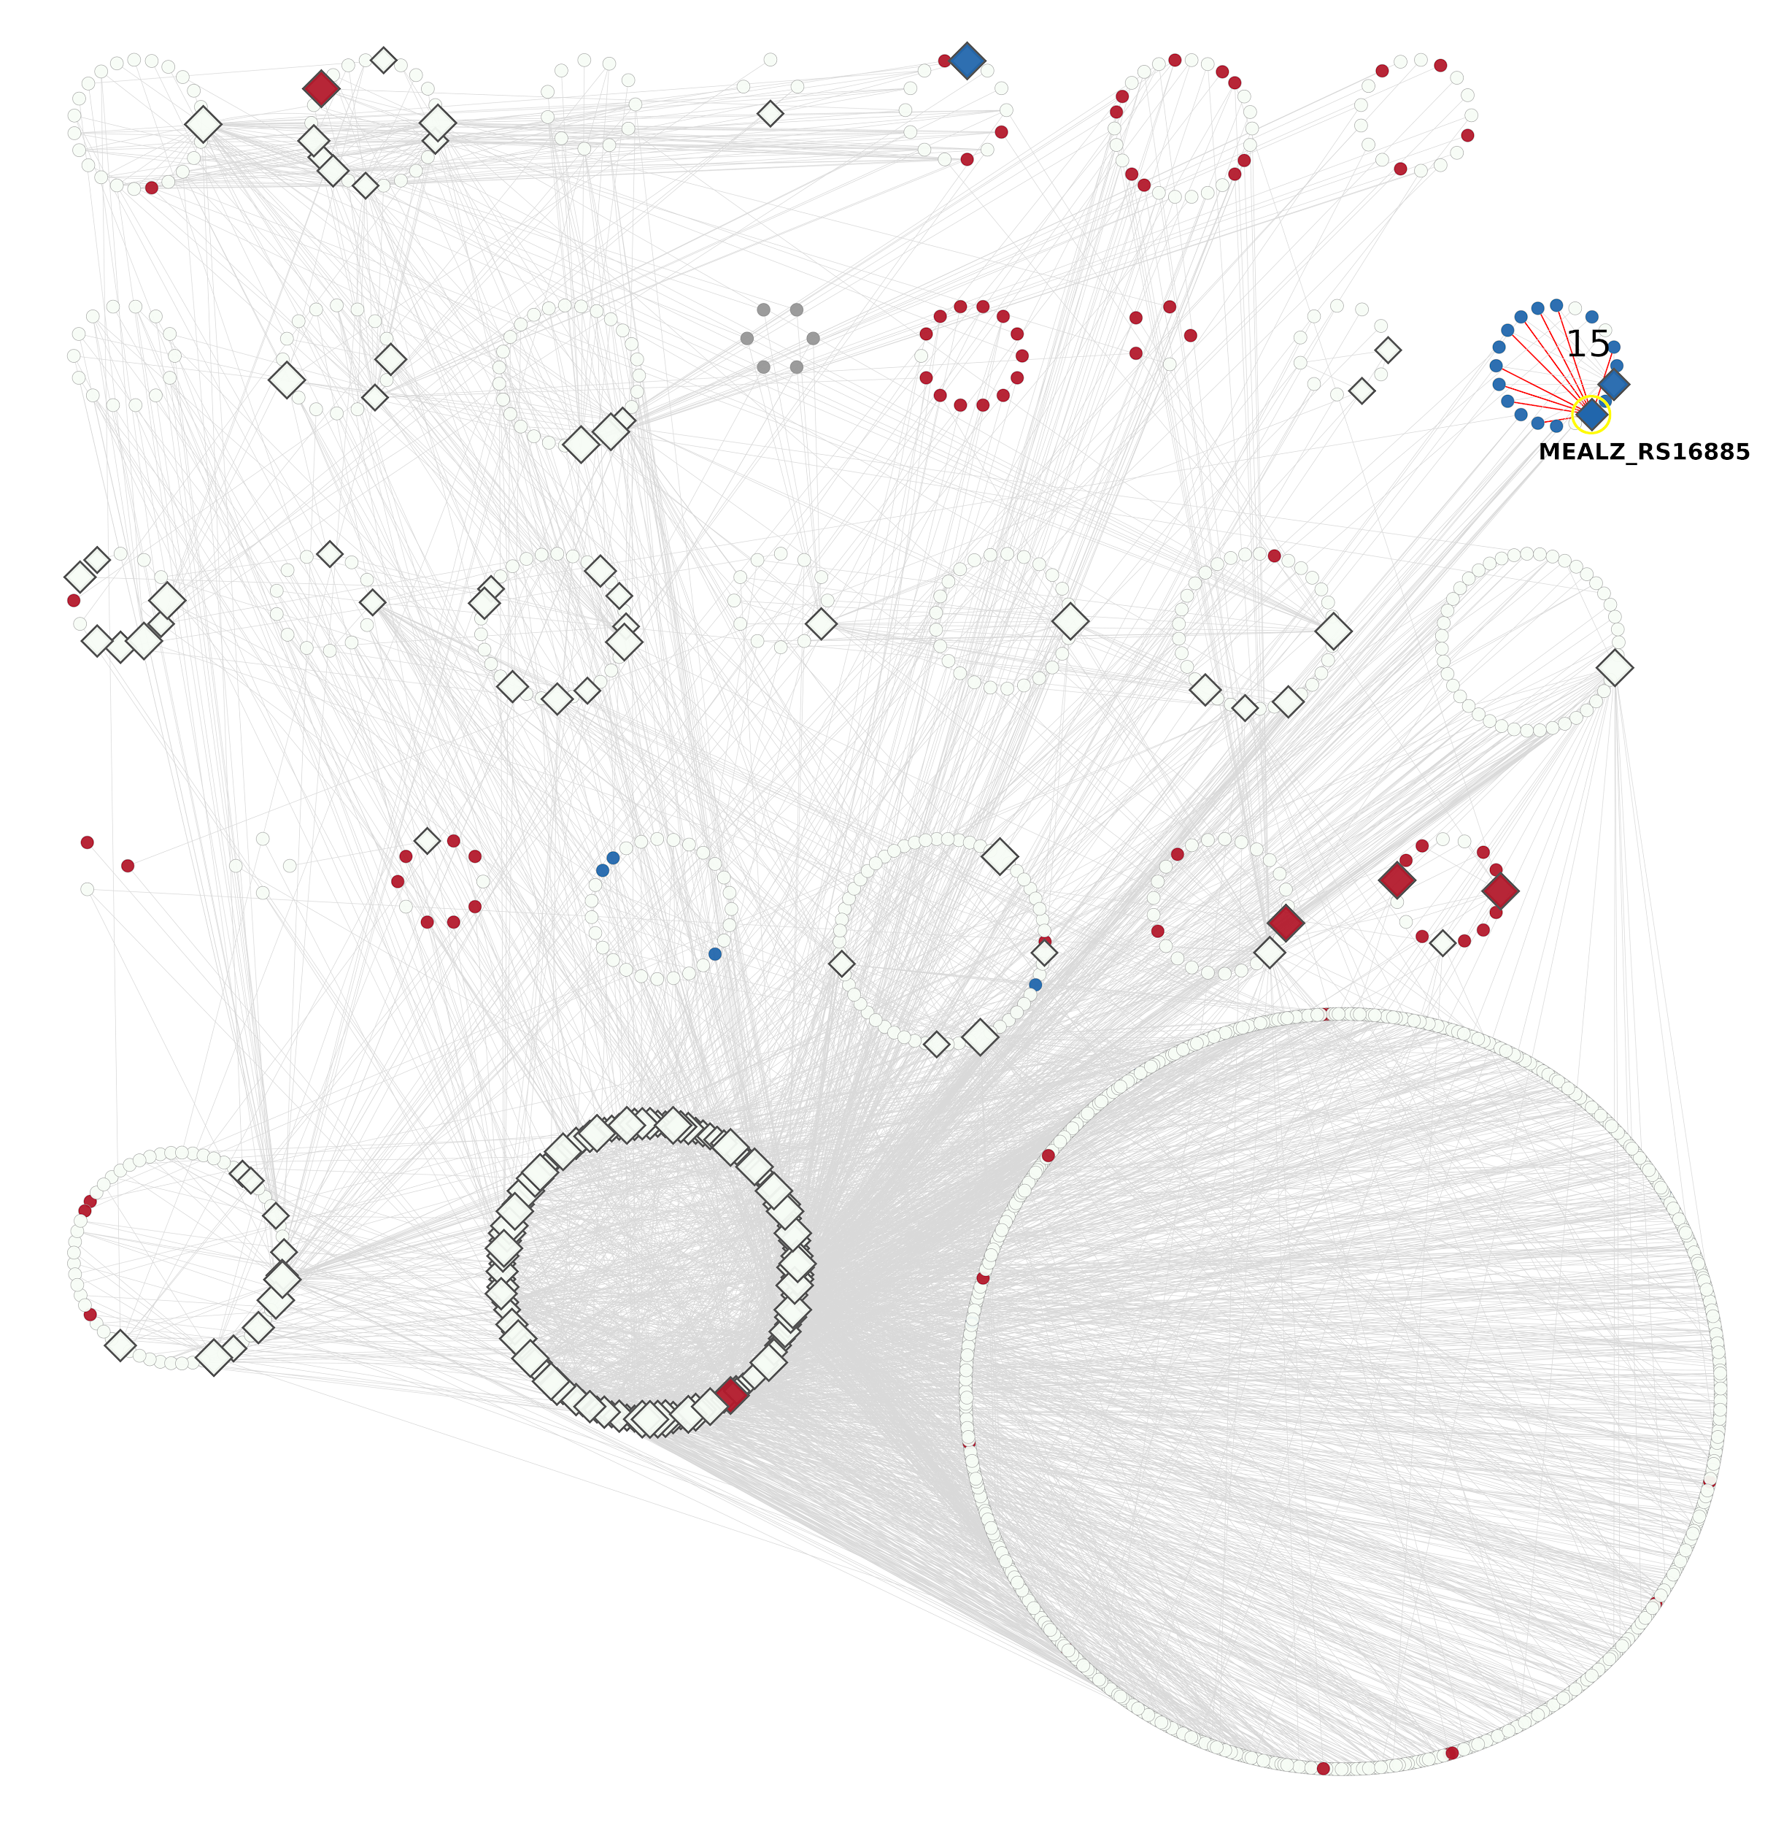**Supplementary Figure 6:** GRN layout based on the GCN clusters. The up-expressed genes in La-grown cells are in red, while down-expressed are in blue. The down-expressed cluster 15 is designated. Clusters 31 (extra TFs) and 32 (extra non-TFs) are at the same position as in Figure 6 (main text). The potential TF (MEALZ_RS16885, *mxaB*) which has a maximum links (red edges) only inside the cluster 15 is highlighted by yellow.

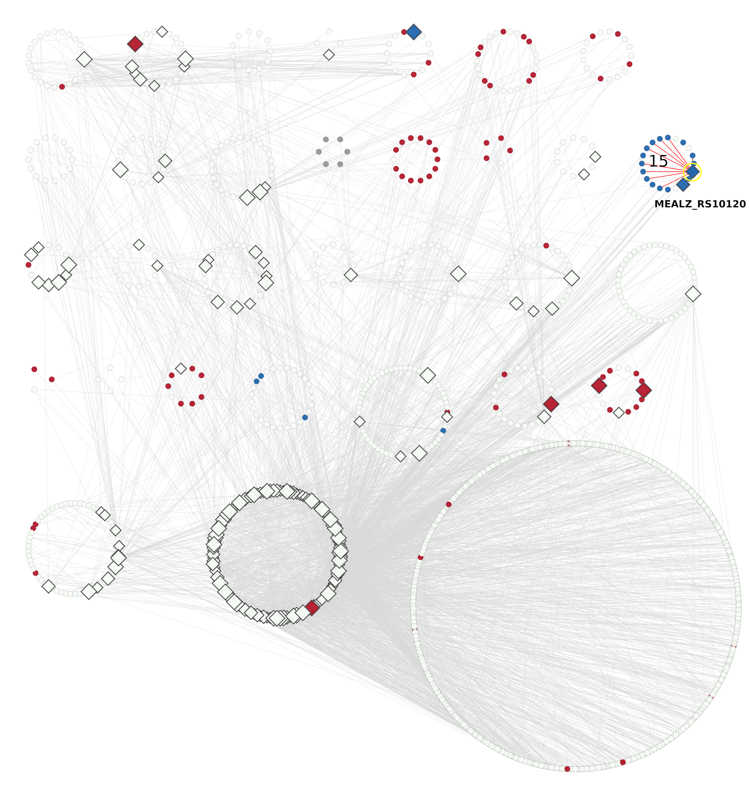

**Supplementary Figure 7:** GRN layout based on the GCN clusters. The up-expressed genes in La-grown cells are in red, while down-expressed are in blue. The down-expressed cluster 15 is designated. Clusters 31 (extra TFs) and 32 (extra non-TFs) are at the same position as in Figure 6 (main text). The potential TF (MEALZ_RS10120) which has a maximum links (red edges) only inside the cluster 15 is highlighted by yellow.